Name:_________________________________________________________ Date:____________________
Guided Notes: Linear Inequalities
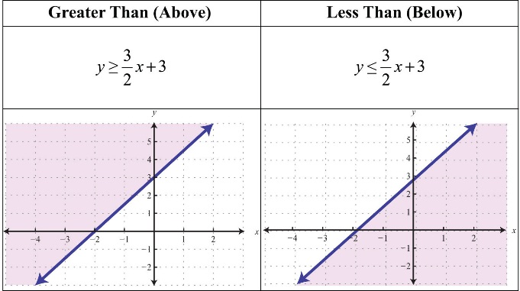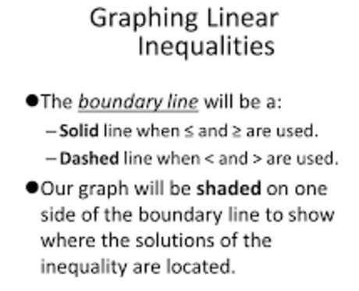
Example 1: Graphing an Inequality
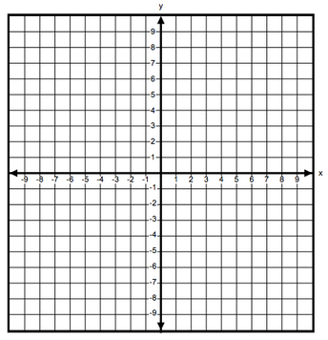
I can graph an inequality on the coordinate plane.

Graph y < 2x +3
#1) Graph boundary line – solid or dashed?

#2) Shade. . . think about y .

#3) Check your shading with substitution.
- pick a point ______
- Substitute it in.

Graph y ≥ 3x - 1
#1) Graph boundary line – solid or dashed?

#2) Shade. . . think about y .

#3) Check your shading with substitution.
- pick a point ______
- Substitute it in.

Got it?________

Got
Example 2: Rewriting to Graph an Inequality
I can rewrite an inequality to graph it on the coordinate plane.

Graph 3x – 5y ≤ 10
#0) Get in y = mx + b

#1) Graph boundary line – solid or dashed?

#2) Shade. . . think about y .

#3) Check your shading with substitution.
- pick a point ______
- Substitute it in.

Graph 6x + 8y > 12
#0) Get in y = mx + b

#1) Graph boundary line – solid or dashed?

#2) Shade. . . think about y .

#3) Check your shading with substitution.
- pick a point ______
- Substitute it in.

Got it?________

Example 3: Using Inequalities to Model Real-World Applications
I can write an inequality to solve a real-world application, and graph it to represent the solution.
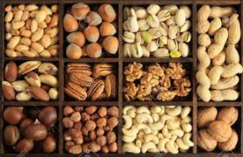
Suppose your budget for a party allows you to pend no more than $12 on peanuts and cashews. Peanuts cost $2/lb and cashews cost $4/lb. Find three possible combinations of peanuts and cashews you can buy.
Define
Sort your numbers out
Write some sentences
Write some equations
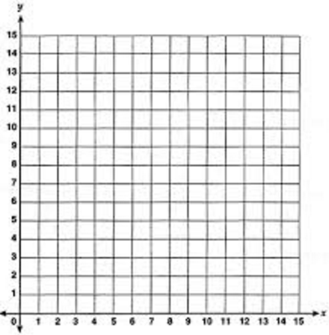
What are some possible combinations for peanuts and cashews you can buy?

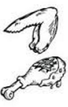
Suppose you plan to spend no more than $24 on meat for a cookout. At your local market, hamburger costs $3.00/lb and chicken wings cost $2.40/lb. Find three possible combinations of hamburger and chicken wings you can buy.

Define
Sort your numbers out
Write some sentences
Write some equations

Graph your graph on desmos.com. Sketch a picture of it here. Include intercepts, a ans labels, and d shading.

What are some possible combinations of hamburger and chicken wings you can buy?

Got it?________

