No:____Name:___________________________________________ 3 Act Lesson Follow Up
Lesson Title: Hot Dogs
http://www.cbsnews.com/news/joey-chestnut-wins-7th-hot-dog-eating-contest-with-record-69-franks/
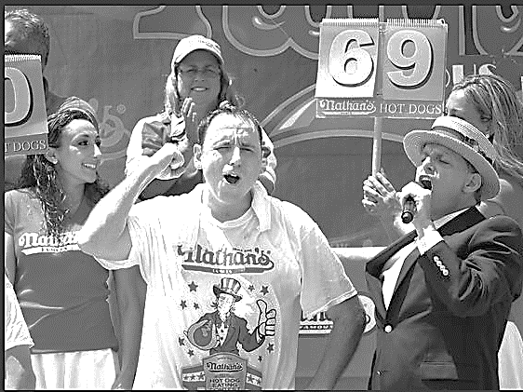
Joey Chesnut has won Nathan’s International Hot Dog Eating Contest 8 times. In order to give other competitors a fair chance, a new, elite hot dog eating competition has started. Here are the rules of the new competition:
- The contest is 16 minutes long.
- After the 16 minutes, each competitor must eat an addition 5 hot dogs.
Joey Chesnut boasts, “I can eat 120 hot dogs in 18 minutes.”
Can he? Or will he be embarrassed on the new, elite, international hot dog eating stage?
Act One:
1. Will he eat 120 hot dogs in 18 minutes?

2. Write down a guess about how many hot dogs he CAN eat in 18 minutes.
Too Low | Official Guess | Too High

2.5 What do you notice? What do you wonder?

Act Two:
3. What information would be useful to figure this out?

4. Write down some questions you have in your head right now.

5. Given Information (from Mrs. O’Mara)

6. Show your math here.

7. Write an equation to match your math:__________________________________________________

Act Three:
8. What was the truth? Can he eat 120 hot dogs in 18 minutes?

9. How close was your guess? What would have allowed you to find a more accurate solution?

STOP. Check and make sure you have answered EVERY question, and have labelled your answers with units.

