Name:__________________________________________________ Date:__________________
Guided Notes: Parallel, Perpendicular, or Neither?
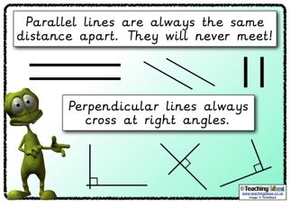
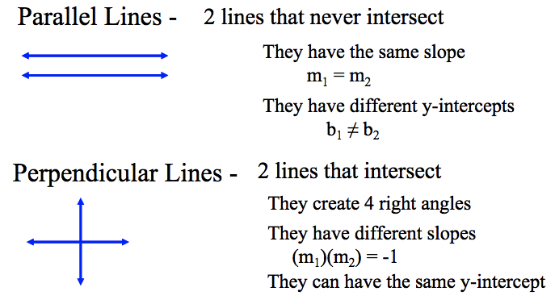
Objective #1: I can determine if a set of equations is parallel, perpendicular, or neither.
I DO 1A: One line passes through the points (–1, –2) and (1, 2); another line passes through the points (–2, 0) and (0, 4). Are these lines parallel, perpendicular, or neither?
Find the slopes | Compare | Solution

Find the slopes | Compare | Solution | Got it?
WE DO 1A: One line passes through the points (0, –4) and (–1, –7); another line passes through the points (3, 0) and (–3, 2). Are these lines parallel, perpendicular, or neither?
I DO 1B: Tell whether the lines for the pair of equations are parallel, perpendicular, or neither
y = –2/3x + 1 2x – 3y = –3
Are these lines parallel, perpendicular, or neither?
Find the slopes | Compare | Solution

WE DO 1B: Tell whether the lines for the pair of equations are parallel, perpendicular, or neither.
y= -7/8x - 1 32x-28y=-36
Find the slopes | Compare | Solution | Got it?
Are these lines parallel, perpendicular, or neither?

Objective #2: I can determine if lines graphed are parallel, perpendicular, or neither.
I DO 2: Tell whether the lines for the pair of equations are parallel, perpendicular, or neither.
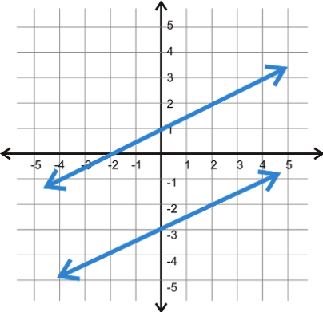
Take a guess
Count the slopes
Compare
Solution

Take a guess
Count the slopes
Compare
Solution
Got it?
WE DO 2: Tell whether the lines for the pair of equations are parallel, perpendicular, or neither.
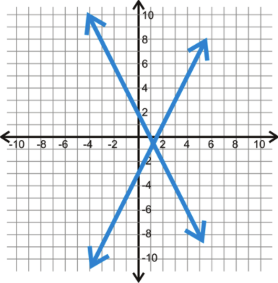

Objective #3: I can write parallel and perpendicular lines for a given equation.
I DO 3: What's the equation of the line perpendicular to y = 3x - 3 and passes through the point (-8, -2)?
Original Slope
What slope do you need? | Needed slope:_____
Substitute point and need slope in.
Equation
WE DO 3: What's the equation of the line parallel to 2x – 3y = 9 and passes through the point (4, –1)?
Original Slope
What slope do you need? | Needed slope:_____
Substitute point and need slope in.
Equation
Got it?

YOU DO: DO YOUR WORK, numbered neatly, on a separate sheet of paper.

Objective 1A: Write the slope of the line parallel and perpendicular to the line that goes through the 2 points.

Parallel slope:_____ Parallel slope:_____
Perpendicular slope:______ Perpendicular slope:_____
Parallel slope:_____ Parallel slope:_____
Perpendicular slope:______ Perpendicular slope:_____

Objective 1B: Tell whether the lines for the pair of equations are parallel, perpendicular, or neither.
5.) 6.) 3x + y = 8 and y = $\frac{1}{3}$x + 8

Objective 2: Tell whether the lines for the pair of equations are parallel,
perpendicular, or neither.

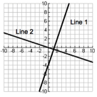
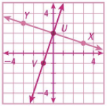
7.) 8.)

Objective 3:

9.)What is an equation of a line perpendicular to the line given by the equation 2x – 5y = 3 at the point (-1,1)?
Original Slope
What slope do you need? | Needed slope:_____
Substitute point and need slope in.
Equation

10.) What is an equation of a line parallel to the line given by 2x + 7y = 5 and containing the point (6, –2)?

Number:______Name:_________________________________________ Date:____________
Exit Ticket: Parallel, Perpendicular, or Neither?

Objective 1A: One line passes through the points (3, -3) and (-3, -1); another line passes through the points (1, 2) and (-1, -4). Are these lines parallel, perpendicular, or neither?

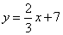
Objective 1B: Tell whether the lines for the pair of equations are parallel, perpendicular, or neither .

2y + 3x = 10

Objective 2: Tell whether the lines for the pair of equations are parallel, perpendicular, or neither.
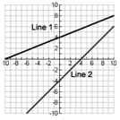

Objective 3: What is an equation of a line parallel to the line given by
9y – 2x = 36 and containing the point (-10, 12)?

