Example #1:
José had 4 times as many trading cards as Phillipe. After José gave away 50 cards to his little brother and Phillipe gave 5 cards to his friend for this birthday, they each had an equal amount of cards. Write a system to describe the situation and solve the system.
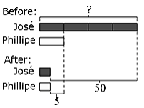

Example #2:
Last season two running backs on the Karr football team rushed or a combined total of 1550 yards. One rushed 4 times as many yards as the other. How many yards were rushed by each player?

Example #3:
A particular Algebra text has a total of 1382 pages, which is broken into two parts. The second part of the book has 64 more pages than the first part. How many pages are in each part of the book?

Example #4  5x – y = 1  3x + 2y = 13 | Example #5  r = 5 – w  2r + 7w = 0 | Steps to Solve a System of Equations by Substitution  1. Solve one equation for one of the variables.  2. Substitute the resulting expression in the other equation.  3. Solve the resulting equation for the first variable.  4. Find the values of the variables by substituting the solution back into the original equation to solve for the second variable.  5. Check the solution in both equations of the system.
Name:_________________________________________ Date:________________________
Using Substitution to Solve Systems of Equations Activity
Directions: Match the system of equations with the modified equation that can be used to solve the system of equations by substitution. Draw a line between the system and the equation used to substitute.

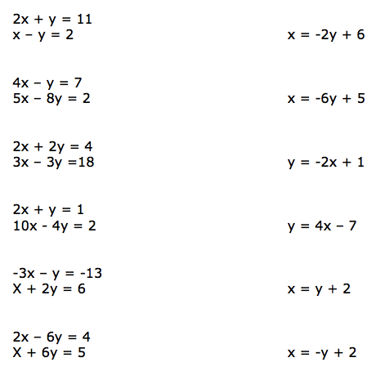

1.)

2.)

3.)

4.)

5.)

6.)

Now, choose two systems to solve completely. Number them and solve in the boxes below.
Number:________  Solution:________ | Number:________  Solution:________

